Instructions to Export a COGNOS WebWise report to Excel

1. Run the selected report and the results will display in HTML.
2. After the result is displayed on your browser, use the dropdown in the top right corner to choose a different format and select ‘View in Excel Options’ and then select the ‘View in Excel 2007 Format’. Alternatively, you may choose ‘View in PDF format’.

Image 1

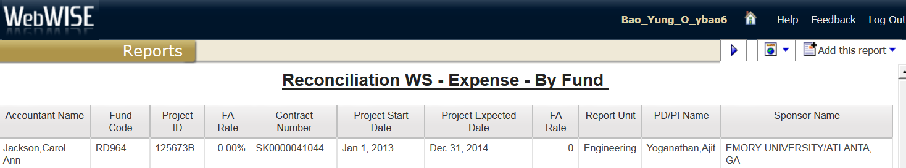

Image 2

