### G&C Notice 21-I

### August 11, 2020

### Faculty Academic Contracts Accounting Update

As you are aware **beginning in August of 2020, academic contract pay will be evenly distributed from the August through May time period**. Georgia Tech faculty with nine-month academic year appointments are currently paid in ten unequal paychecks distributed from mid-August through mid-May. In August, with the start of the 20-21 academic year, faculty pay for the full academic year will be distributed in 10 ***equal*** payments from August through the following May.

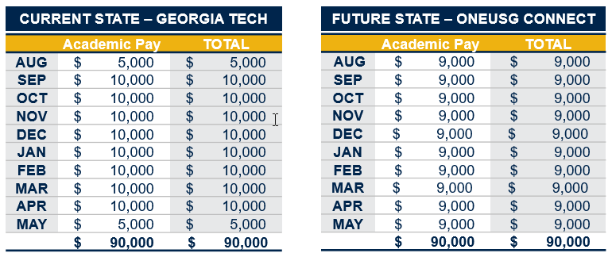

In order to maintain compliance with Federal Requirements and to avoid over charging any external sponsors, an accounting entry will be made within the OneUSG Connect Commitment Accounting module to align the salary earned with the appropriate accounting period. This will allow the accounting records to mirror the nine-month pay schedule. **This will not impact the amount an employee receives via payroll.**  Offsetting accounting entries will be handled centrally, with no impact to departmental budgets.

**How does this work?**

An example of the accounting is below and shows an employee allocated 10% to an external sponsored Grant and 90% to a department Instruction Designated. This shows how the monthly distribution will be displayed in Commitment Accounting, Workday, and Workload Assignment forms.



In the above example each month the Institute level Designated will be charged with a calculated amount that converts the payroll paid evenly over ten month to align with the 9 months of effort, this includes the half months in August and May. The Grant and Department level Designated will display the 9 month pay schedule and be allocated based on the Commitment Accounting records. The clearing designated will net to zero at the end of each semester.

The Academic Contract pay process will also take into account Funding Changes and Express Direct Retro transactions processed in Commitment Accounting. The department will not need to make any adjustments to the Institute Clearing Account this will all be system generated. This process will not impact the summer or additional pay. This process will only impact regular salary included as part of contract pay.

There are additional details to be worked out and we understand you may have further questions. There will be additional guidance provided as we move forward.